<https://www.cnblogs.com/minseo/p/11548177.html>

<https://www.runoob.com/docker/docker-compose.html>

docker-compose –version

docker-compose up -d

docker-compose stop

<https://www.cnblogs.com/minseo/p/11548177.html>

# [Docker Desktop启动Kubernetes](https://www.cnblogs.com/weschen/p/12658839.html)

<https://www.cnblogs.com/weschen/p/12658839.html>

<https://docs.docker.com/docker-for-windows/kubernetes/>

# [Kubernetes基础：Pod的详细介绍](https://www.cnblogs.com/cocowool/p/kubernetes_pod_detail.html)

<https://www.cnblogs.com/cocowool/p/kubernetes_pod_detail.html>

# [First steps with Docker and Kubernetes - Introduction](https://techcommunity.microsoft.com/t5/windows-dev-appconsult/first-steps-with-docker-and-kubernetes-introduction/ba-p/357525)

<https://techcommunity.microsoft.com/t5/windows-dev-appconsult/first-steps-with-docker-and-kubernetes-introduction/ba-p/357525>

1：启动Kubernetes

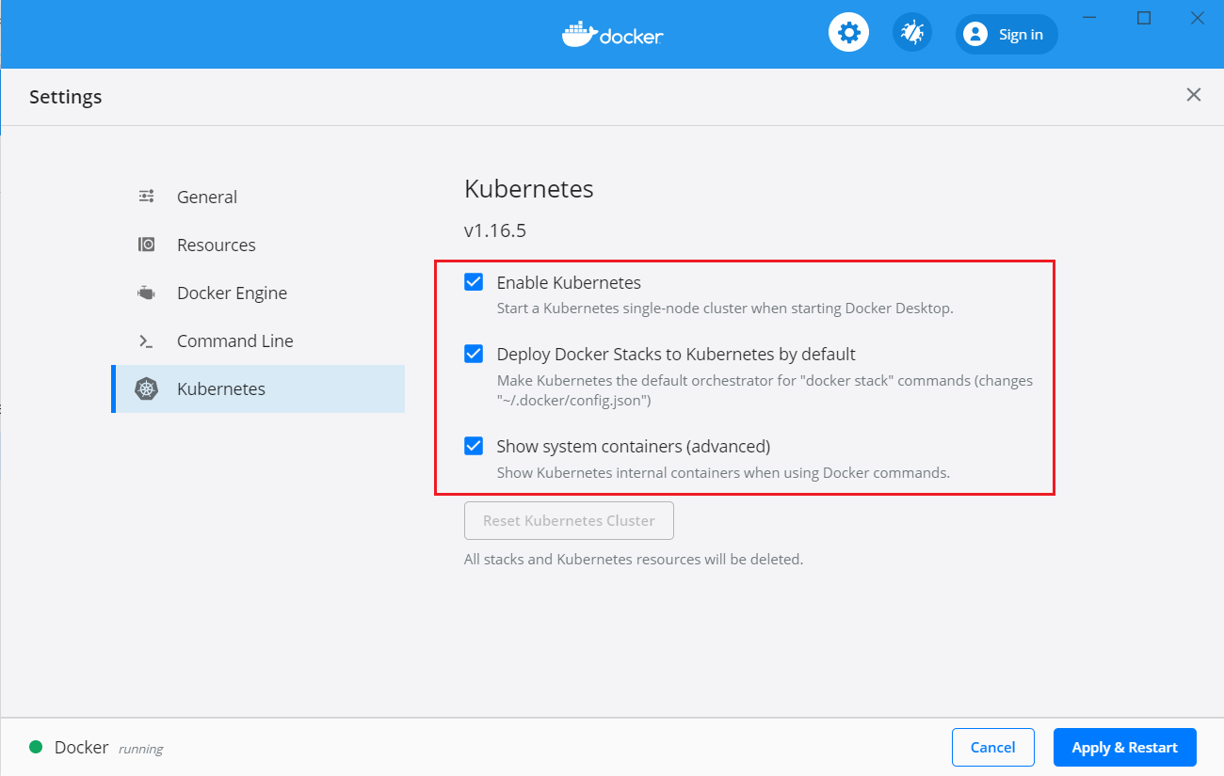

2: 查看是否启动成功：kubectl cluster-info

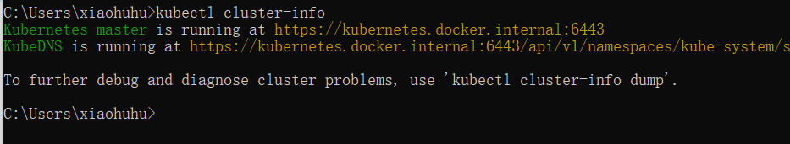

查看版本：kubectl version

3：查看nodes：kubectl get nodes

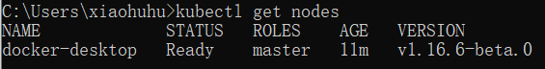

We are connected to the cluster that Docker Desktop has created for us, which has only one node. However, right now the cluster is empty. There are no applications running. So let's create one!

4：这篇文章介绍的kubectl命令已经过时了

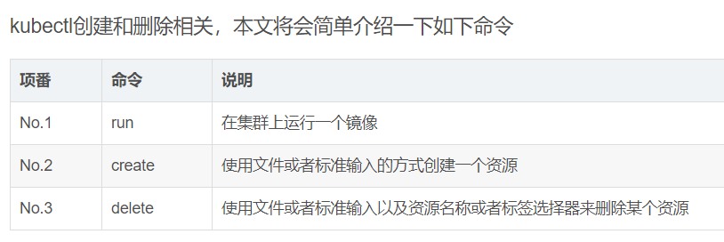

<http://docs.kubernetes.org.cn/490.html>

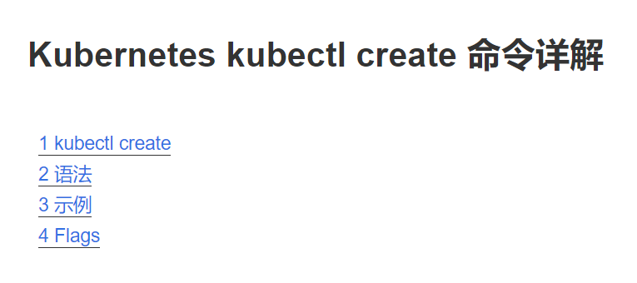

<https://www.cnblogs.com/miclesvic/articles/10997060.html>

5：从命令或文件中创建资源

kubectl create deployment nginx --image=nginx:1.14

kubectl create -f my-nginx.yaml

6：在集群中运行一个指定的镜像

kubectl run nginx --image=nginx:1.16 --port=80 --replicas=1

7：查看部署的节点

kubectl get deployments

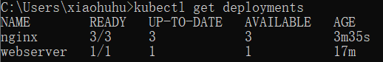

8：查看pods：kubectl get pods

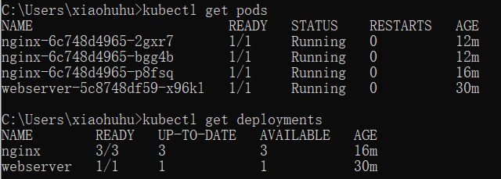

这里有个问题，为什么一个容器一个pod？

不应该是多个容器在一个pod中嘛

<https://techcommunity.microsoft.com/t5/windows-dev-appconsult/first-steps-with-docker-and-kubernetes-introduction/ba-p/357525>

A pod can host one or more containers even if, typically, each pods maps a single container.

9：扩容：kubectl scale deployment nginx --replicas 5

10：删除pod：kubectl delete pods webserver-5c8748df59-x96kl

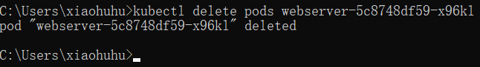

再使用kubectl get pods 我们会看到kubenetes又帮我们建了个pod出来。

这是因为kubenetes认为这个pod还在使用中，不应该删除。

11：把容器暴露到网络：kubectl expose deployments webserver --type=LoadBalancer

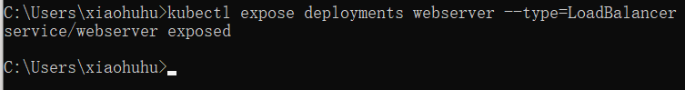

12：查看service：kubectl get services

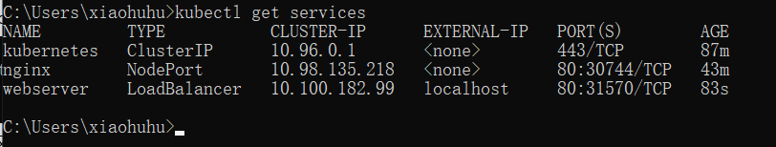

13：此时，访问<http://localhost/> 就可以看到niginx服务了

14：如何扩容

kubectl scale deployments webserver --replicas=5

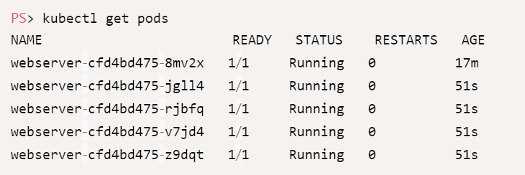

### Deploy a multi-tier application

15：docker stack deploy --compose-file .\docker-compose.yml mywebapp

Kubernetes is able to update pods gradually, to make sure that there's always one or more instances up & running, which means no downtime for the users.

完整的发布流程：

源码：

<https://github.com/Microsoft/Windows-AppConsult-samples-PWA/tree/master/Docker>

cd testwebapp

docker build -t "qmatteoq/testwebapp" .

docker push qmatteoq/testwebapp

后面的发布流程是：在本地把源码打包成镜像，上传到dock hub(或其他平台的镜像仓库)。 再通过Kubernetes将镜像下载，发布到容器、部署到Pod。

Windows Azure的Kubernetes服务 (AKS)

<https://docs.microsoft.com/zh-cn/azure/aks/supported-kubernetes-versions>

<https://blog.51cto.com/wuyvzhang/2366546>

需要注意的事项：

1：网络

2：身份认证

3：监控

Azure容器注册：<https://www.cnblogs.com/AllenMaster/p/13518676.html>

Azure上使用Kubernetes服务的大致流程：

1：新建Azure Container Registry

2：将本地的项目通过Dockerfile，进行打包，然后将 Images push 到容器注册表中

3：在Azure上创建仓库，将docker image推送到自己的仓库

4：登录Azure，查看

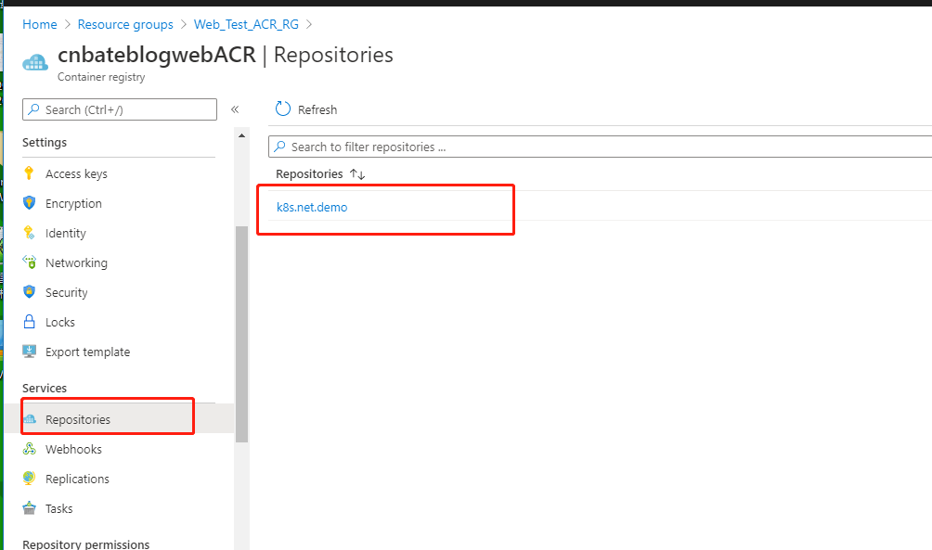

Azure K8s service的使用

<https://www.cnblogs.com/AllenMaster/p/13541680.html>